1. Packet captured includes DNS packets, ARP packets
2.
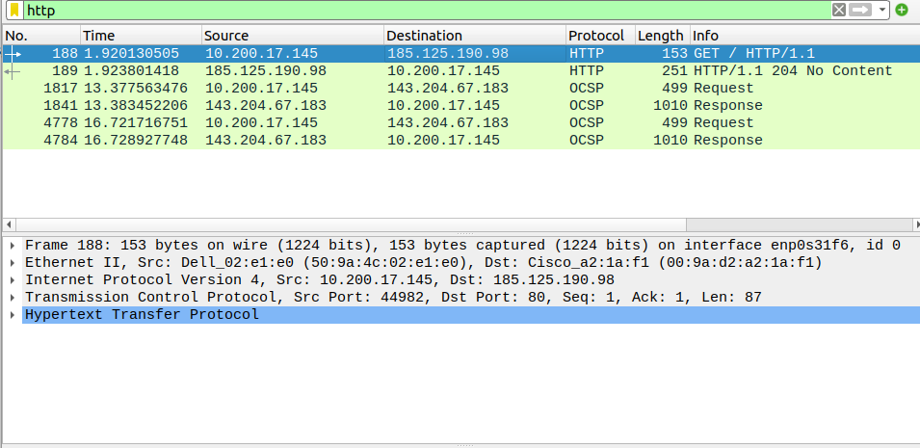
Open a webpage while the it is capturing, apply filter to find http packet

3.

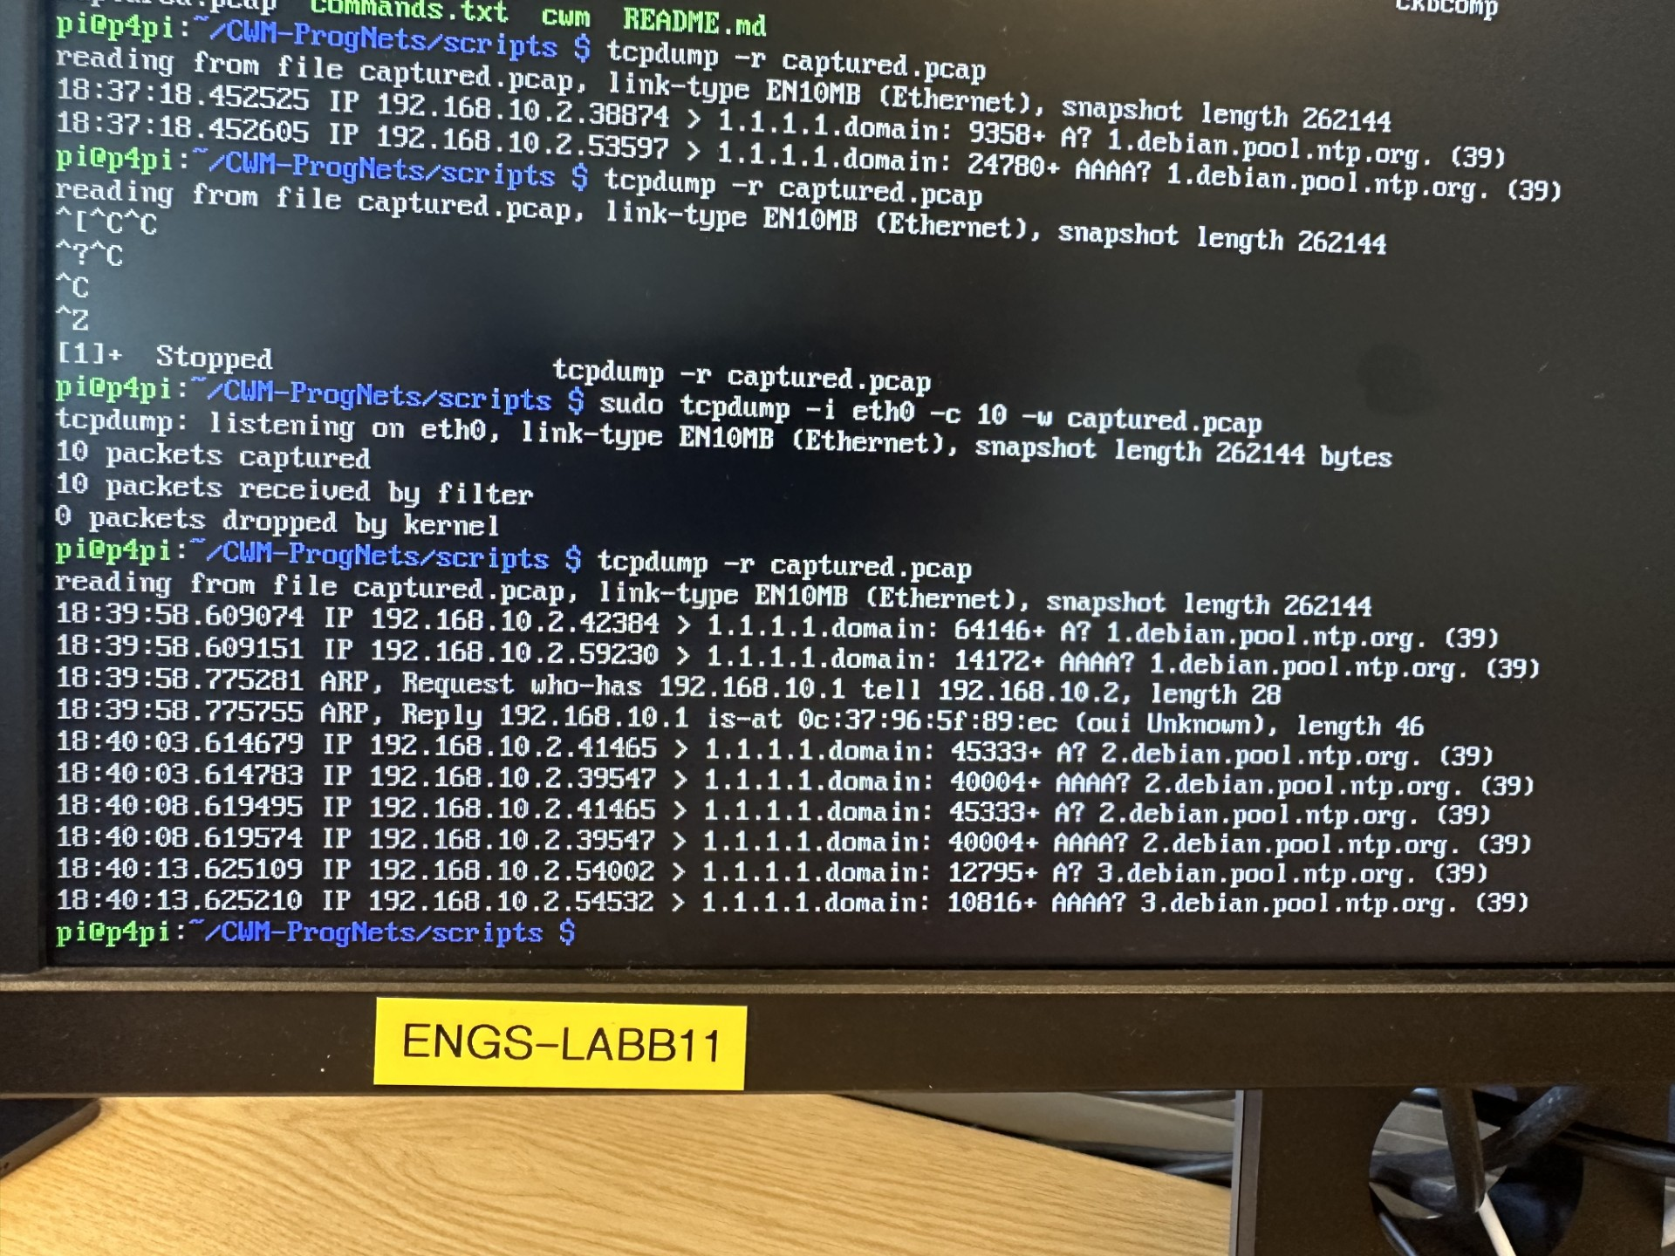
.

4.

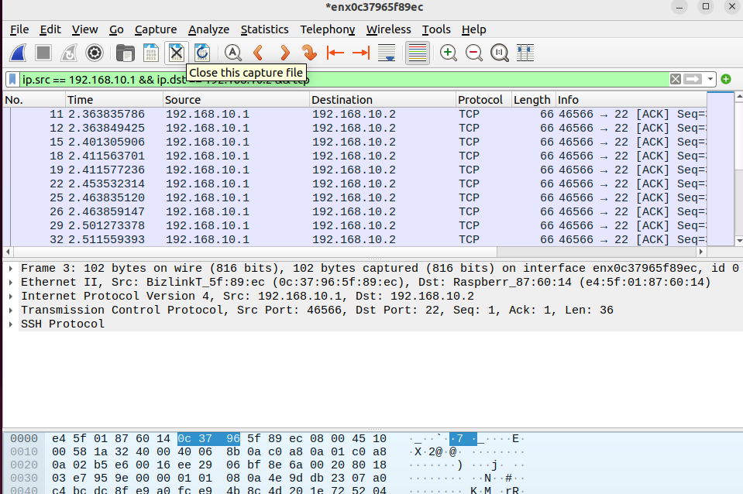
filter as shown
size = 66 bytes
protocol = TCP

Modified script

https://github.com/Sitaoooo/CWM-ProgNets/tree/e3733c251662bbd947ab7acf5acc4fd80a29f02d/assignment1

